ACTIVITY

Lab Worksheet

Hypotheses
Activity 1.
High Withdrawal and Recharge

Activity 2.
Point Source Pollution

Observations
Activity 1.

The water flown through the sand and gravels, and formed a water reservoir of clean water.

Activity 2.

The point source pollutant eventually contaminated the entire ground model and the water in it.
Activity 3.
The water from permeable layer was purer that that from the one obtained from impermeable layer pond.

Activity 3.
Non-Point Source Pollution

Photographs
Activity 1

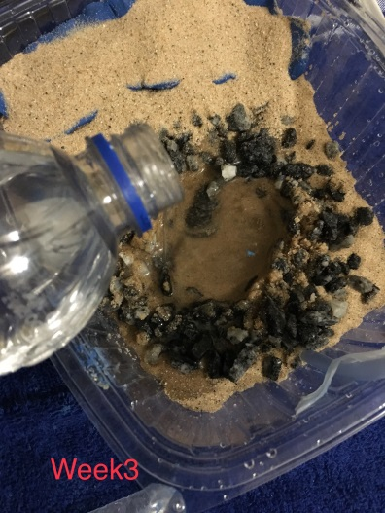
Activity 2.
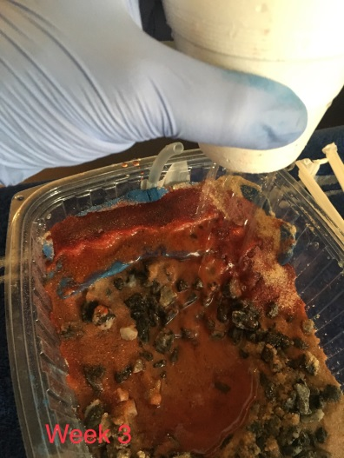
Activity 3.

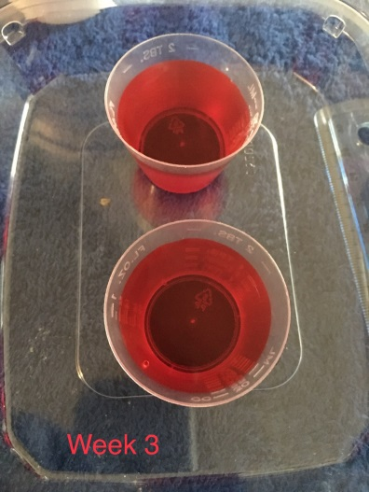
Lab Questions
Please answer the following entirely in your own words and in complete sentences: Introduction
- Background—What is important to know about the topic of this lab? Use at least one outside source (other than course materials) to answer this question. Cite the source using APA format.
The theory of hydrosphere comprises of all the water in the globe and how it circulates. Water in the oceans, rivers and lakes evaporate into vapor which condense at high atmospheres and fall back to the earth in form of precipitation. The water is infiltrated into ground water below the water table and the rest flows on the ground into rivers, lakes and oceans and the cycle repeats itself. In between the process, there are various pollutants which may contaminate the water at the different stages of circulation. These are obviously human activities which affect the water cycle and they should be avoided.

- Outcomes—what was the main purpose of this lab?
- To be able to describe the importance of the availability of fresh water to the human population
- Construct multiple groundwater and surface water models and analyze different ways the water can become contaminated.
- Distinguish between point and non-point pollution sources and explain the impact of each

- Hypotheses—What were your hypotheses for the activities of this lab? Identify each hypothesis clearly, and explain your reasoning.
My hypothesis for the lab activities were:
1: High Withdrawal and Recharge. This activity is aimed at learning about the importance of water cycle and how water withdrawal and recharge processes generally affect the environment but not necessarily in a balanced state.
2: Point Source Pollution. The activity aims at displaying how pollutants play a major role in the water cycle and how they cause blocking and contamination of ground water when they land on an impermeable layer.
3: Non-Point Source Pollution. The activity displays the difference between water obtained from a well confined under an impermeable layer and that obtained from a pond confined on a well permeable layer.

Materials and Methods
- Using your own words, briefly describe what materials and methods you used in each of the activities. Your answer should be sufficiently detailed so that someone reading it would be able to replicate what you did. Explain any measurements you made.
Materials used:
- Clay, ¼-pound Sand, 4 cups Gravel, 2 cups blue bar, Plastic cup, Permanent marker
- Plastic container, 64 ounces, Kool-Aid® drink mix packet, 2 Pieces aquarium tubing
- 2 Plastic tubes, 3 Straws, Syringe, 10 mL, Disposable pipet, Foam cup
Methods used:
Activity 1:
1. Place a block of clay in the plastic container so it is one-third of the total distance away from one side of the container. This piece of clay will act as an impermeable retaining rock, so make sure to mold the clay so that it fits tightly on the sides and on the bottom of the container.
2. The smaller section will represent the reservoir and the larger section will be the aquifer, as seen in Figure 5.
3. Take one of the clear plastic tubes (not to be confused with the aquarium tubing), and cut it in half with a pair of scissors. These two cylinders will model wells drilled into the ground to reach the aquifer.
4. Add just enough sand to cover the bottom of the aquifer section, spreading the sand with your hands to level it out.
5. Place the two cut plastic tube pieces (wells) upright in the sand near the edge of the container in the aquifer farthest from the clay bar at random areas (see Figure 5). Ensure that each well is seated firmly against the bottom of the container.
6. Add another layer of sand, making sure to have the sand slightly higher up on one well than the other.
7. Form the next layer of the aquifer by adding enough gravel to cover the sand while creating a slight incline. Form the top of the incline around the wells. The gravel hill should slope downward toward the retaining wall (clay) and should be even with the top of the clay.
8. To represent precipitation, poke approximately 10 holes in the bottom of the foam cup and fill it with water (over the model), allowing the water to sprinkle onto the top of the slope, near the edge of the container behind the wells. Some water may leak into the reservoir.
9. Fill the smaller section (the reservoir) with water until the water level rises a few centimeters over the clay retaining wall.
10. The top of the water table is represented by the height of the water in each of the wells.
11. Insert a straw into one of the wells until it touches the bottom. Hold your forefinger tightly over the open end of the straw to create a seal, and then remove the straw from the well. Use the permanent marker to draw a line to mark the top of the water level in the straw. This line represents the top of the water level in the aquifer.
12. Using a disposable pipet, drain this well by squeezing the round bulb of the pipet before putting it into the water, putting the pipet tip down into the water, and releasing the bulb to suck up the water. This water can be placed in a cup for disposal. Use the pipet to empty all the water in this well. (There may be a mixture of sand and water removed.)
13. As soon as you have removed all the water in the well, place the straw back into the bottom of the well and remove a water sample as you did in Step 11. Mark the top of the water column with a permanent marker as before. This represents the level of water in the well after a period of high withdrawal. Record your observations in the “Observations/Data Tables” section of the Lab Worksheet.
14. Wait 2 minutes and observe what happens to the drained well. Measure the water level again using the straw and permanent marker, and note if the height of the water table has changed in the “Observations/Data Tables” section of the Lab Worksheet. Has the height of the water table decreased or increased? Take a photograph, zooming in on the markings on your straw to show how much the water level has changed. Upload this to the “Photographs” section of the Lab Worksheet.
15. If needed, refill the reservoir with water until the water level rises a few centimeters over the retaining wall (as in Step 9).
16. Repeat Steps 11–14 using the other well.
Activity 2:
If the water from the reservoir in Activity 1 has a large amount of sand in it, pour it into a bowl and remove any excess sand from the reservoir. Do your best to let only water drain from the aquifer section, keeping all other materials (clay, sand, gravel, and tubes) in place. Continued on next page 10 Carolina Distance Learning
2. Take one of the thinner, flexible aquarium tubes and cut it in half. This will act as a discharge pipe from an industrial plant.
3. Tape the aquarium tube half to the inside of the plastic container in the reservoir, making sure the opening is not touching the bottom of the container.
4. Fill the reservoir with clean water until it is just above the top of the clay.
5. Take a cupful of water and pour a small amount of Kool-Aid® drink mix into it (just enough for the water to change color). Mix well. This will represent the waste (pollutant).
6. Use the 10-mL syringe to suck up the waste.
7. Attach the end of the syringe to the aquarium tube, and inject the waste into the aquarium tubing (discharge pipe) you created.
8. Observe and record what happens to the water in the reservoir as you pump the waste into the discharge pipe in the “Observations/ Data Tables” section of the Lab Worksheet.
9. Next, insert a straw into one of the wells until it touches the bottom. Hold your forefinger tightly over the open end of the straw to create a seal, and then remove the straw from the well (as in Activity 1) to see if the polluted water has made its way into the groundwater supply.
10. To verify, wait 1 minute and repeat Step 9; then wait another minute and repeat the step again.
11. Take a photograph of your model with your straw in the picture to help show if there is any pollution occurring in the groundwater supply.
12. After you have completed this activity, obtain a medium- to large-size plastic bowl/container. Take a handful of the gravel and sand mixture. Rinse water through it, separating the gravel (in your hand) from the sand and water mixture (now in the bowl). Place the gravel on a paper towel to the side; let the excess water drain into the bowl, either in the sink or outside on the ground, being careful to retain as much sand as possible in the bowl. Reuse the sand and gravel for Activity 3. If weather permits, this step can be done outside for easier cleanup.
Activity 3:
- Take the bar of clay from the previous activity, and flatten it out as much as possible, making an approximate 6 × 6 cm square.
- Cut the remaining aquarium tube in half, taping one piece to the inside (on a short side) of the plastic container, midway down. Tape the other half of the aquarium tube opposite the previous one and at the same depth in the plastic container. These tubes represent wells (see Figure 6).
- Choose one side of the container, and fill it with sand to a depth slightly higher than the bottom of the well, as shown in Figure 7.
4. On the other side, make a slope of sand a few centimeters higher as you continue placing sand throughout the container. Supplement this layer with a layer of gravel on top, continuing the sloped approach (see Figure 8).
5. Place the flattened piece of clay on top of the uphill side, and mold the clay so that it fits tightly around the well (see Figure 9). This will act as an impermeable layer.
6. Top the model with a thin layer of sand, continuing with the sloped approach.
7. In the sand/gravel mixture at the bottom of the hill, dig a small circular hole. Using a plastic cup from the equipment set, pour water into the hole to represent a pond (see Figure 10).
8. Take the opened Kool-Aid® drink mix packet and sprinkle the remaining contents along the surface of the sloped land. This will act as fertilizer on the landscape.
9. Put water (without Kool-Aid® drink mix) in the foam cup, and shake the cup along the land to simulate rain. Observe what happens to the fertilizer and how it affects both the underwater and pond water (by tracking the now-colored water), and record your observations in the “Observations/Data Tables” section of the Lab Worksheet.
10. Wait 30 seconds, and then use the 10-mL syringe to pump water out from the well that is not surrounded by the impermeable clay layer. Observe the color of the water that came out of the well along with the pond water color. (Some sediment may be sucked into the syringe during this step). Record your observations in the “Observations/Data Tables” section of the Lab Worksheet. Take a photograph of your model with the syringe in the picture to show the color of the water. Upload this to the “Photographs” section of the Lab Worksheet.
11. Now use the syringe to draw water from the uphill well that is confined by an impermeable layer. Observe the color of the water that came from this well. (Some sediment may be sucked into the syringe during this step). Record your observations in the “Observations/Data Tables” section of the Lab Worksheet.
Discussion
- Based upon the results of each activity, explain whether you accepted or rejected your hypotheses and why.
Activity 1: the water flow cycle majorly involves two processes: withdrawal of water and recharge of water. Withdrawal of water from the earth is mainly through evaporation from water reservoirs such as lakes, rivers and oceans while recharge occurs through precipitation which then flows back into rivers, lakes and oceans through surface water or underground water. I agree with the hypothesis since the activity’s results showed the same flow of water cycle.
Activity 2: point source pollutants such as large industries which dispose their wastes through drainages into drinking water reservoirs cause great water pollution. I will agree with the hypothesis because our point source pollutant in the experiment ended up contaminating the entire water reservoir.
From activity 3, the water obtained from the pond located on a permeable layer was cleaner than the water obtained from the pond confined under an impermeable layer. Therefore, I would agree with the hypothesis that impermeability holds underground water pollutants which contaminate the underground water.

- What important information have you learned from this lab? Use at least one outside source (scholarly for full credit) to answer this question. Cite the source using APA format.
Answers should be 5–7 sentences in length.
The main things I learned from this lab were the flow of water cycle, water pollution and the difference in pollution according to the permeability of the ground. The water cycle is a simple cyclic process which starts at the water reservoirs, and then water evaporates into vapor and condenses to form clouds which therefore fall as precipitation back to the ground. It the flows back to the various water reservoirs through surface run or underground flow. Point source water pollution is a major disaster of water pollution which should be handled with the immediate effect. When sourcing drinking water, it is advisable to source it from a permeable layer since it is more pure than that from an impermeable layer.

- What challenges did you encounter when doing this lab? Name at least one.
The challenge faced in this lab was the lack of the standard model to show the water cycle.

8. How might a scientist use the information in this lab to identify and correct water issues in your community?
Scientists can use the information from this lab to correct the issue of water pollution. This can be achieved through the sensitization of the community on the effects of water pollution. The scientists can also develop ways of eliminating the pollutants on the impermeable layer through chemical process which should not have any negative effects to human health.

Literature Cited
9. List the references you used to answer these questions. (Use APA format, and alphabetize by the last
Name.)
Unland, N. P., Cartwright, I., Rau, G. C., Reed, J., Gilfedder, B. S., Atkinson, A. P., & Hofmann, H. (2013). Investigating the spatio-temporal variability in groundwater and surface water interactions: a multi-technique approach. Hydrology and Earth System Sciences, 17(9), 3437.
Barthel, R., & Banzhaf, S. (2016). Groundwater and surface water interaction at the regional-scale–a review with focus on regional integrated models. Water resources management, 30(1), 1-32.
Now copy and paste your answers into the Lab Report provided. Include the data tables and photographs. You may wish to make minor edits to enhance the flow of your resulting lab report.

